**SCS 2104 Programming 3**

**Take Home Assignment - 2018**

Name :- W.D.T.D.Alwis

Admission number :- 2016/cs/005

Index number :- 16000056

**Database:**

User name :- root

Password :- root

**Application’s :**

User name : - admin

Password :- admin

**Standalone University management system for NSBM green university**

1. Requirements
2. EER diagram
3. Relational schema
4. Class diagram
5. Design pattern and the architecture
6. User Interfaces.

Requirements

Users:

Admin

Functional requirements

Should be able to,

* Manage student details
* Manage Staff details.
* Manage Lab, course, subjects details.
* Send emails.

EER diagram.

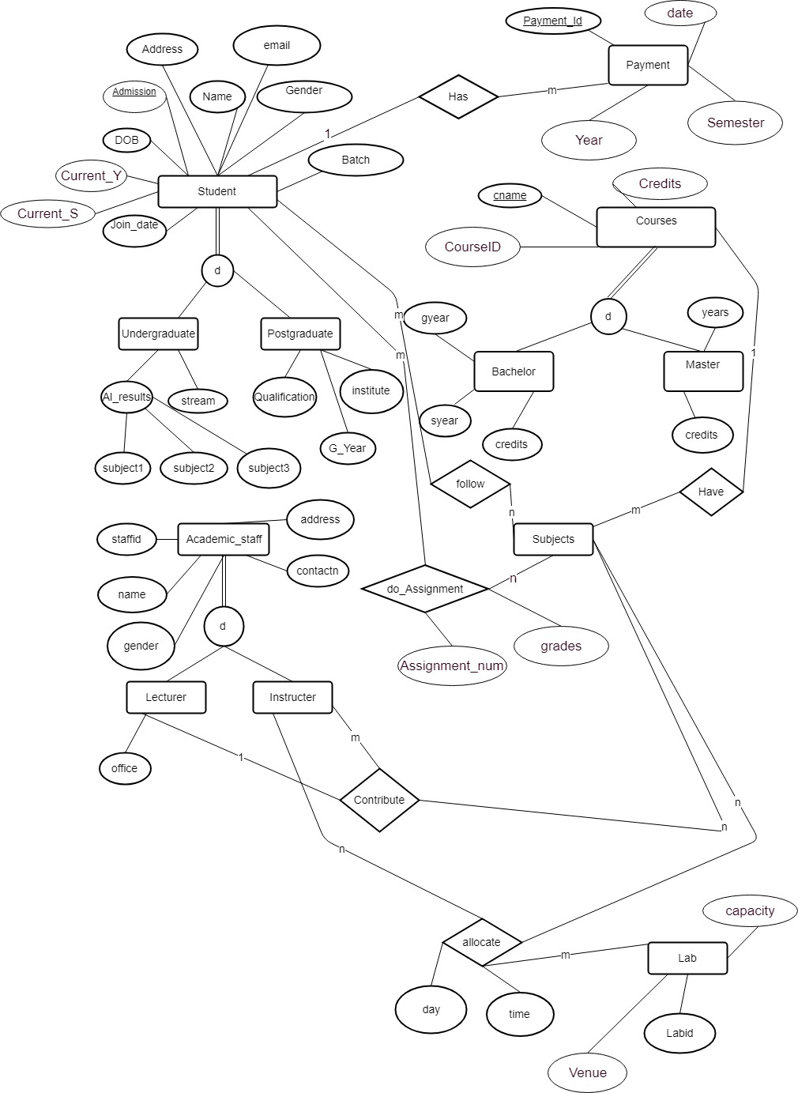

Relational schema

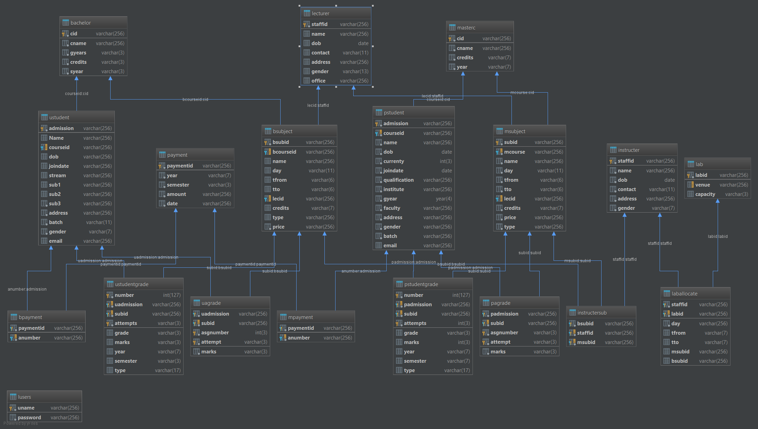

Class diagram

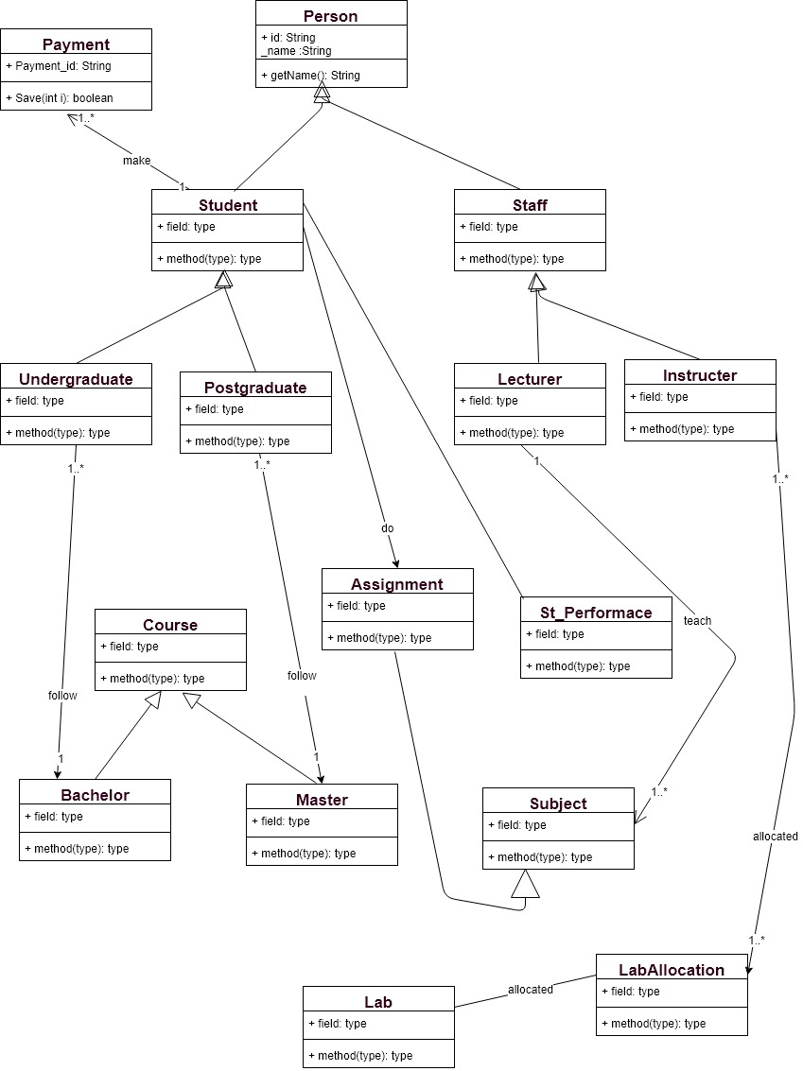

Architecture used here is,

MVC.

Design pattern is,

Singleton pattern is used for database connectivity.

**User Interfaces**

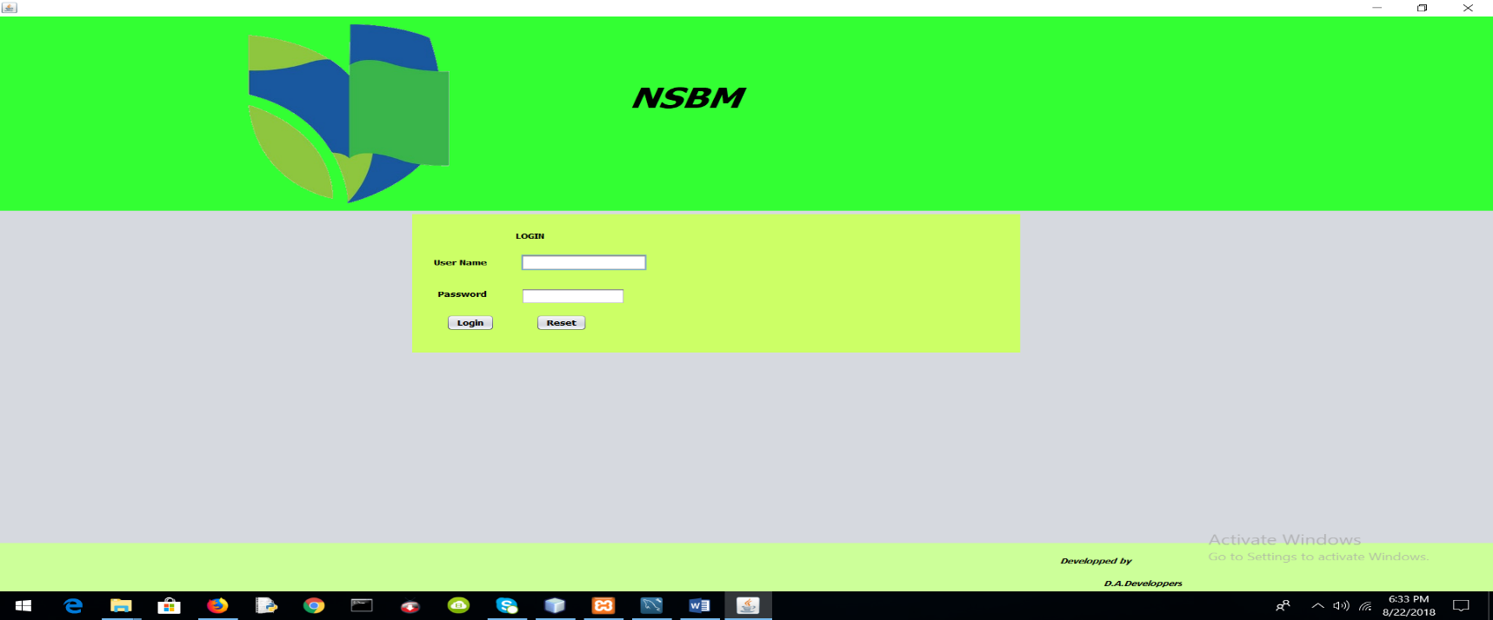**Login**

Allow admin to login

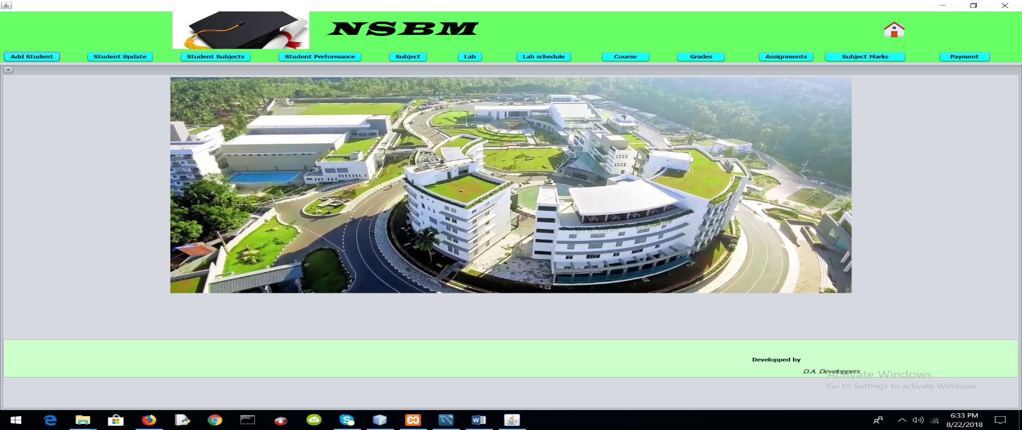**Home page**

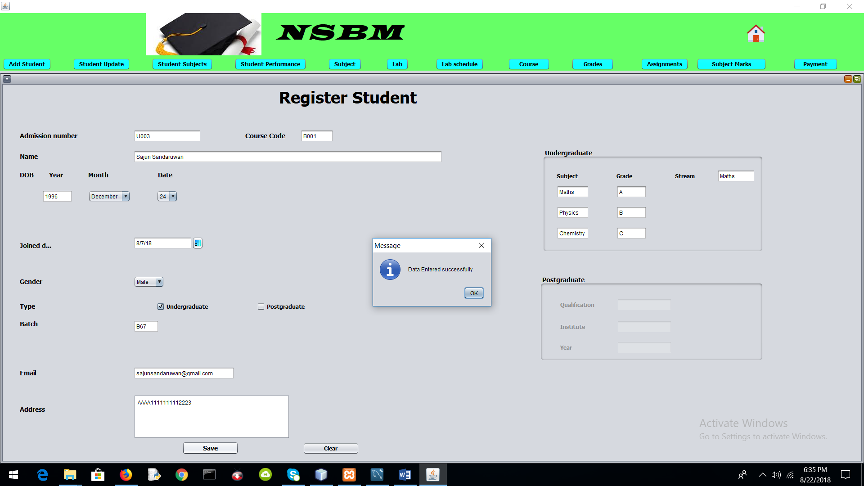 **Register Student**

Student registration form

**Form to manipulate student data**

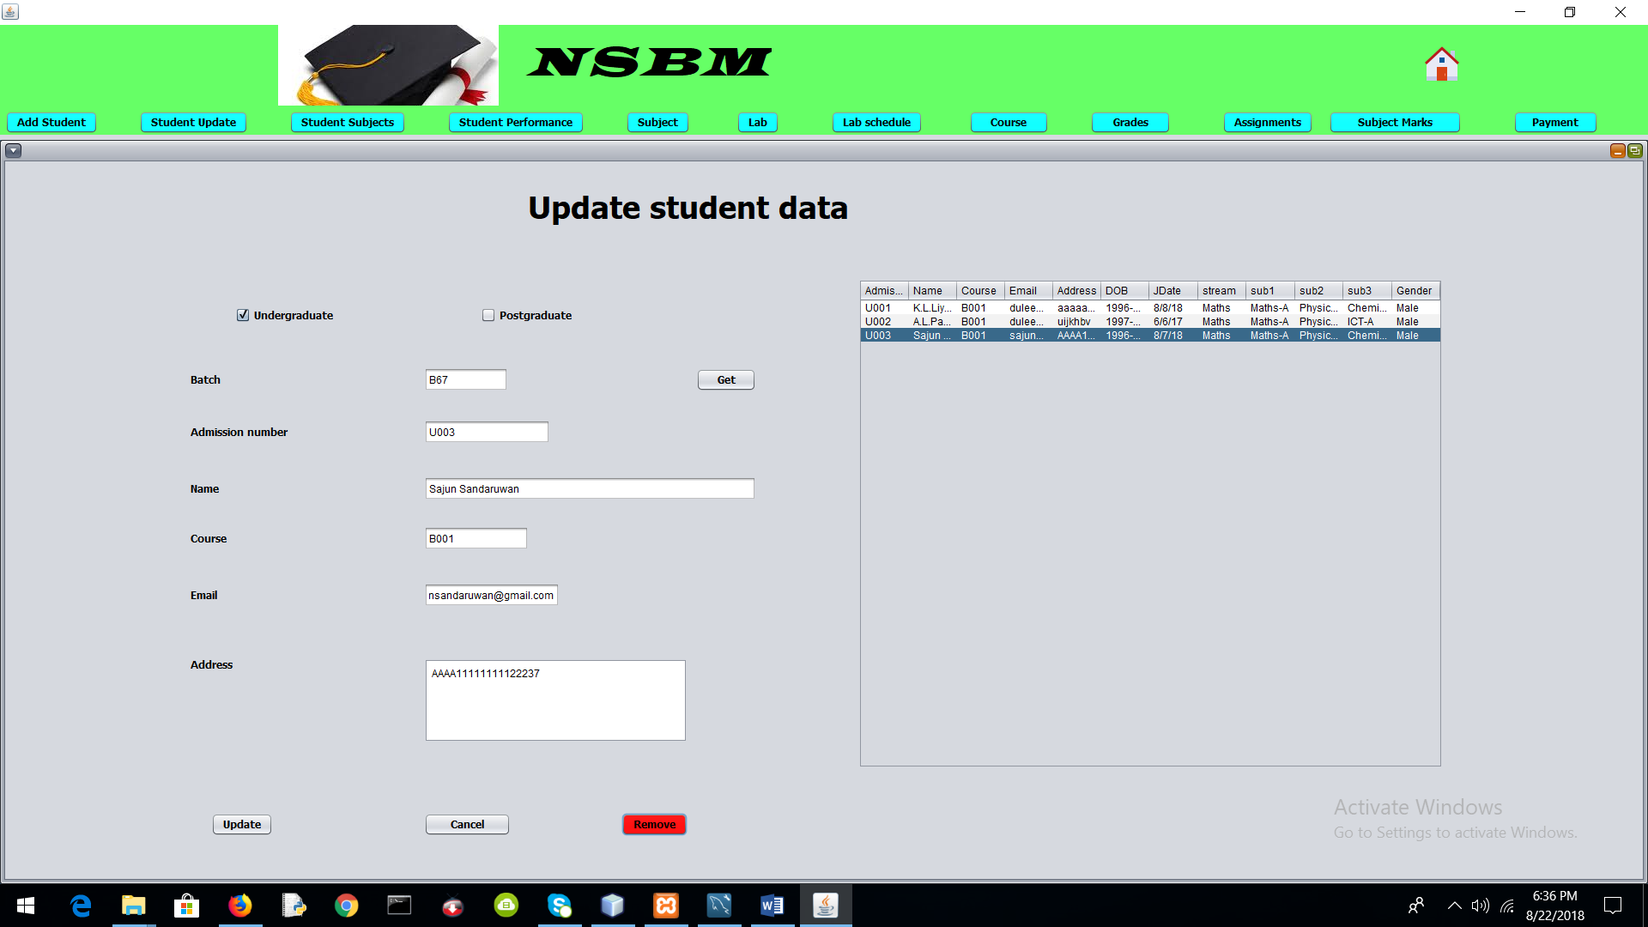

Allow to view, update , remove student details

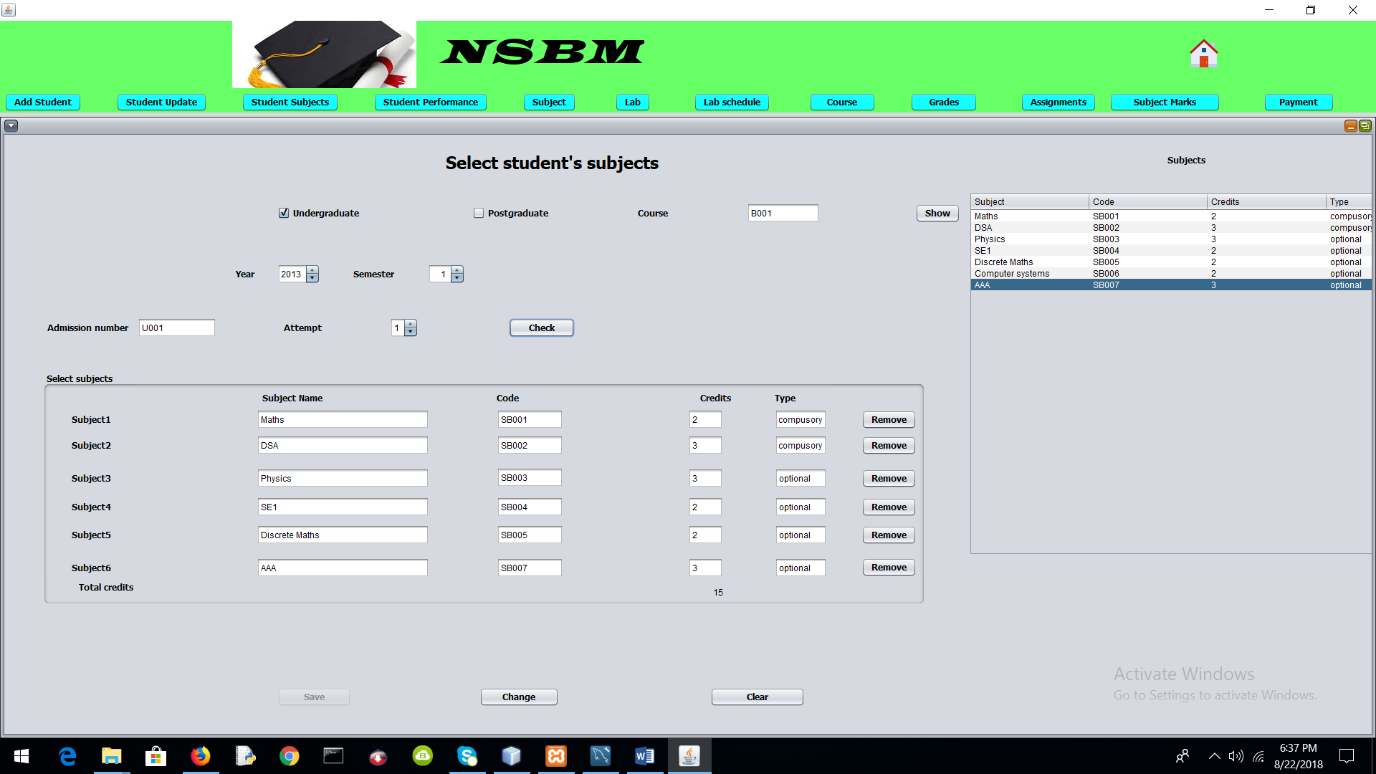**Student’s subjects selection form**

Subjects can be selected according to course student follows and can change the subjects.

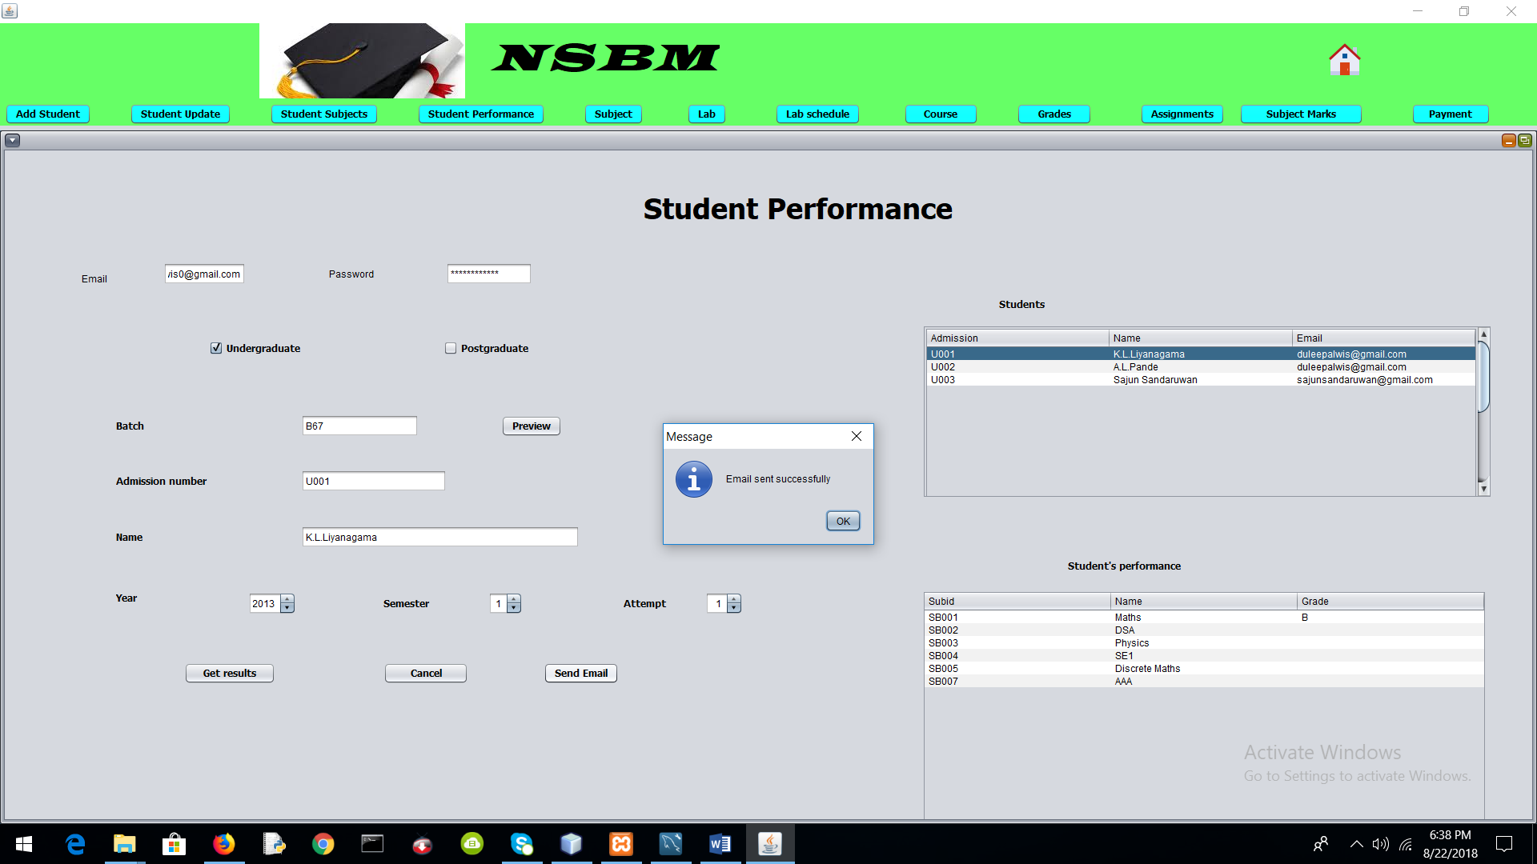**Student performance form**

Allow to view each student’s subject grades according to the year and semester and email it to the corresponding student’s email.

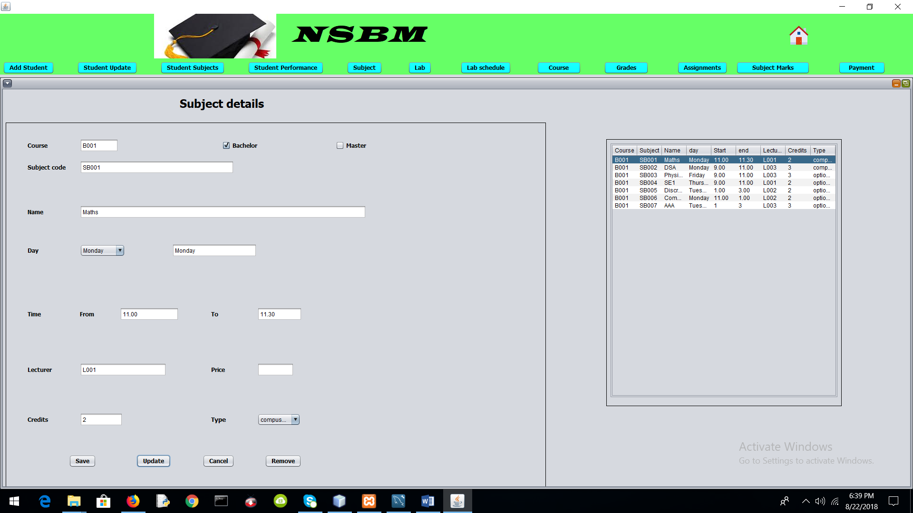**Form to maintain subject details**

Allow enter new subjects, edit, remove subjects.

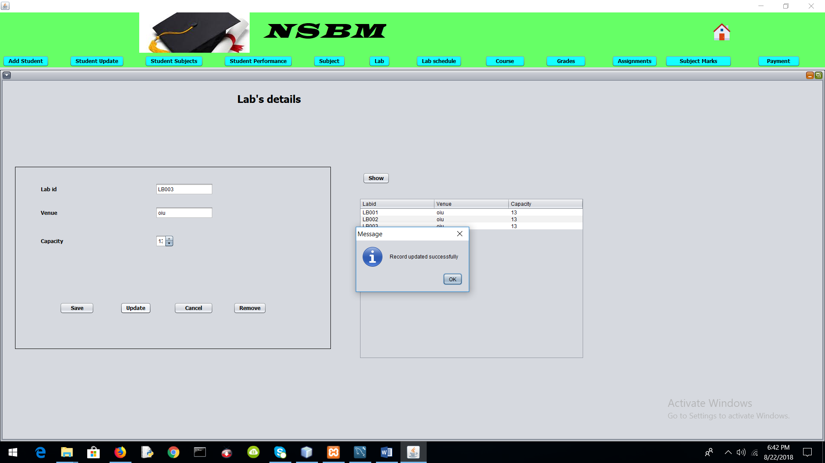**Lab details form**

Allow to view, add , remove , update Lab details

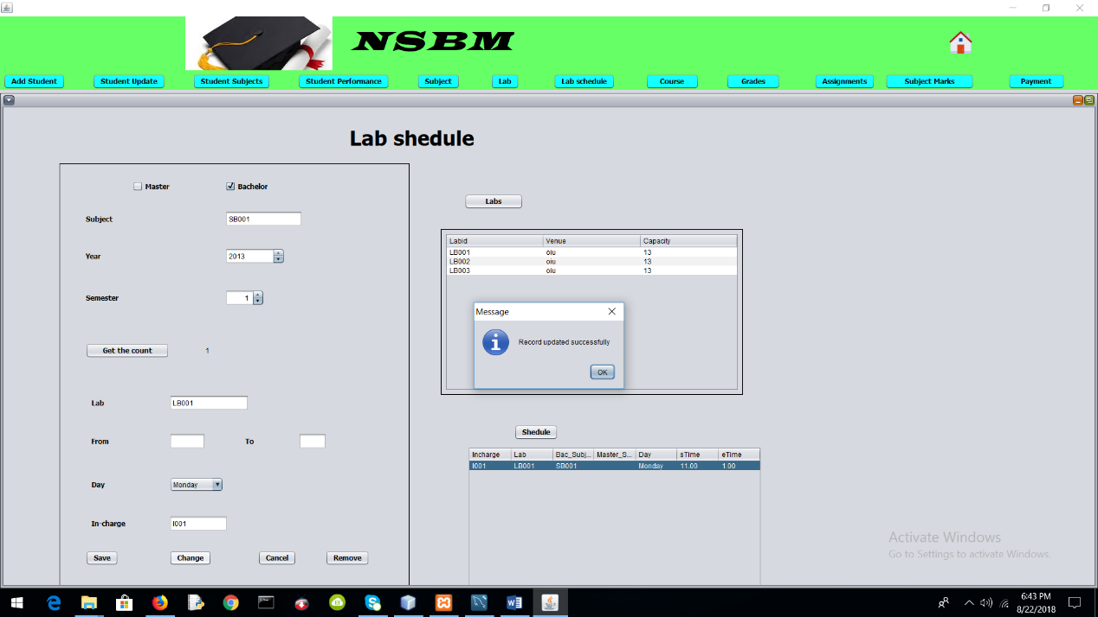**Lab schedule form**

Allow to view, edit schedule of the labs.

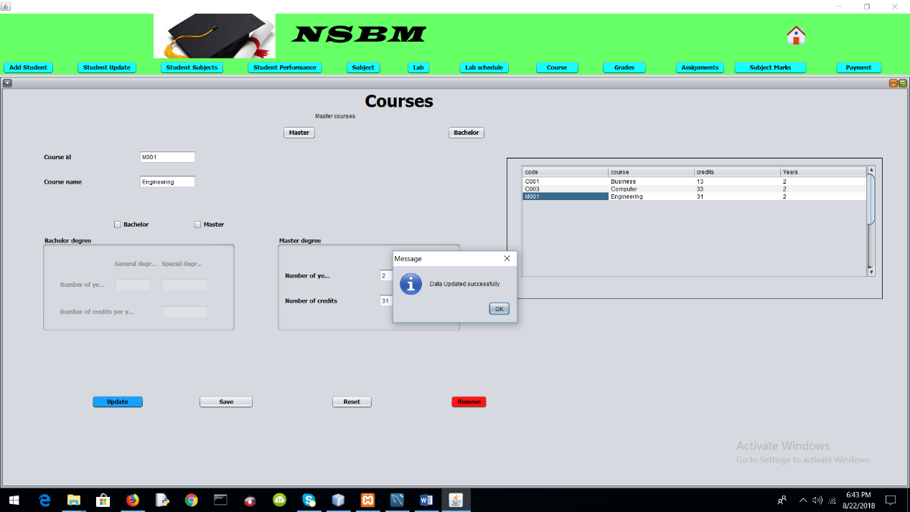**Course details maintaining form**

Add, remove , Change course details.

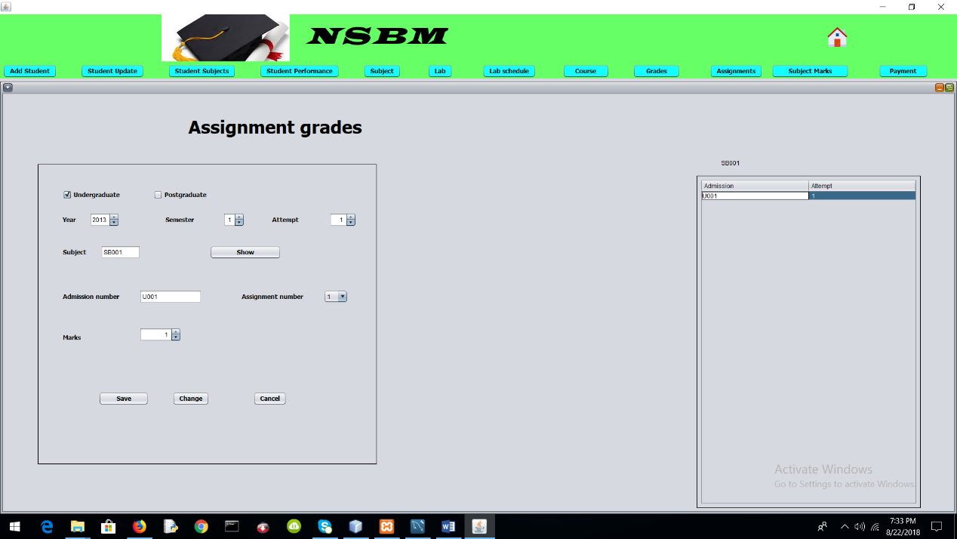**Form to maintain student assignment grades**

Add, change student’s assignment grades.

**Form to maintain student’s subject grades**

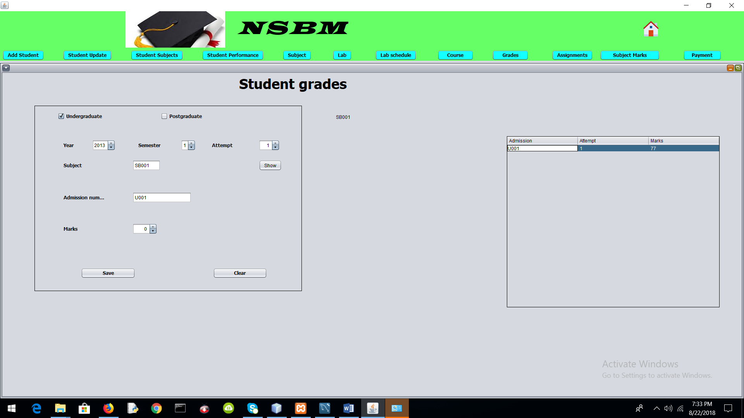Add, change student marks for subject

**Form to calculate student grades**

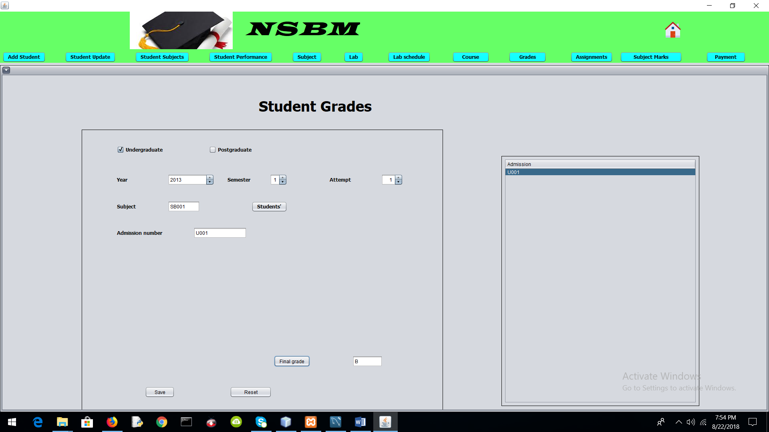

Can view who are the students’ follow a particular subject and can calculate their grades according to assignment and final exam marks.

**Form to maintain student payment**

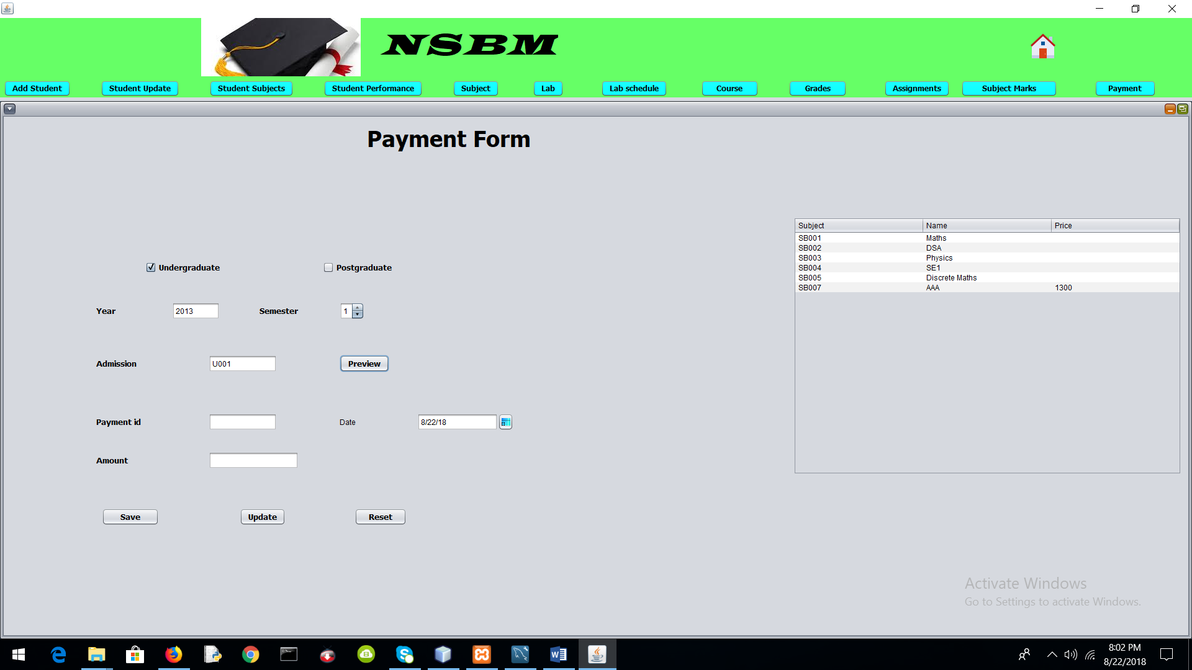

Allow add payment details to the system.